Project-

Student Marks Predictor and Key logger

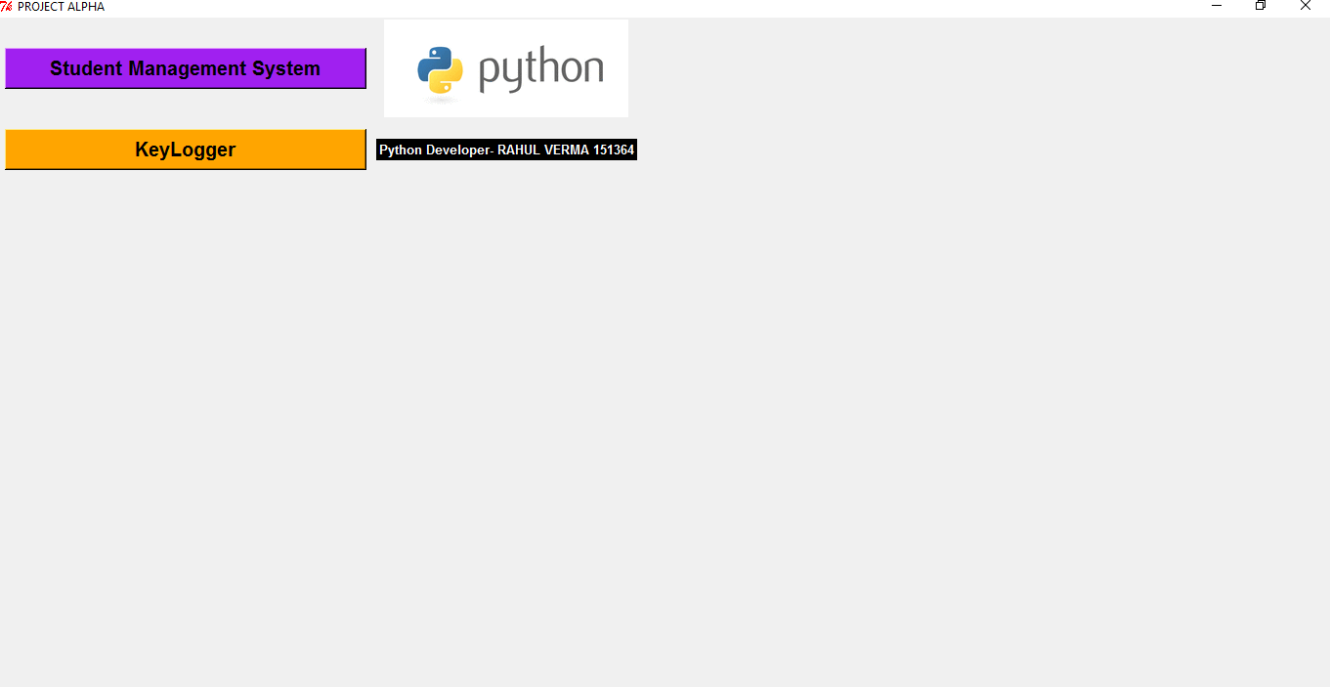

Requirements-

1. Python 2.7 or greater
2. Pyhook,pywin32 package
3. Pyttsx package
4. Smtplib package
5. An internet connection for automatic email sender

*It has* ***speech to text conversion*** *enabled, so you will hear a voice also.* ***Don’t click*** *on any button unless voice has stopped or else the project will hang.*

*Automatic mail sender will work only for my Gmail id because the code has my email address stored in it. If you want to use it for your id, then change the email address in source code.*

*Also you have to check on (****turn on less secure apps)*** *option in Gmail account settings for automatic mail sender.*

***DESCRIPTION-***

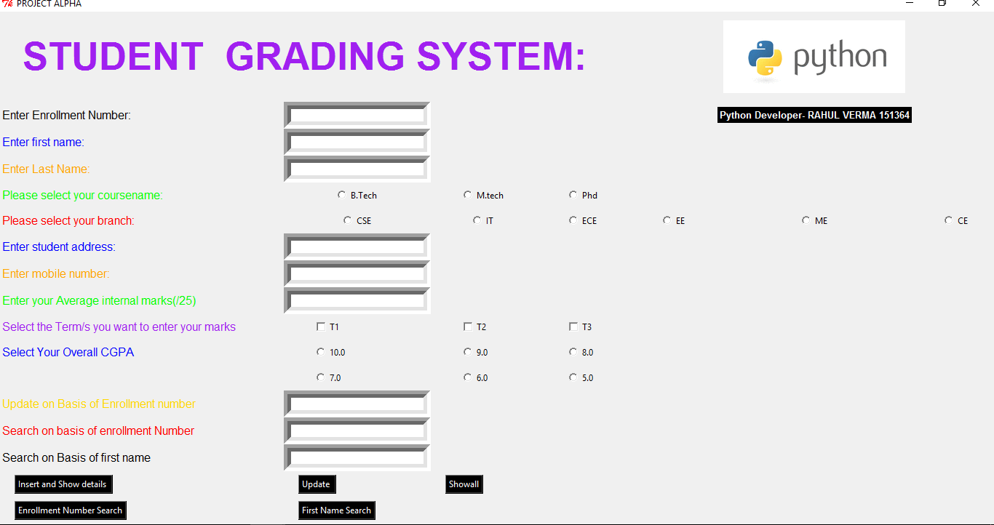

*The first part of my project is a* ***Student marks predictor*** *that tell your marks in t2 or t3 based on your performance in t1 or t2.*

*It basically tells the marks you have to get in order to obtain SGPA of your choice. It uses University Grading Norms like for 10.00 GPA you will have to get 80+ out of 100, 70+ out of 100 for 9.00 and so on.*

*It is based on the* ***marking system of Jaypee University for Computer Science Students.*** *It will ask all your details like name, enrolment number, address, branch, degree , phone number etc. Then it will ask your average internal marks .You now will select t1, t2, t3 checkbox and the SGPA you want at end your semester.*

*If you know the marks of t1 and want to know the marks of t2, t3 you will enter your marks in t1.If you know the marks of t1, t2 and want to know the marks in t3, you will enter your marks in t1, t2.*

*For example if you enter your marks in t1, it will predict you marks in t2, t3.*

*After entering your marks, click on* ***insert and show details*** *button. After clicking, a pop box will appear showing your required marks. It is having options for* ***enrolment number search*** *and* ***first name search.***

*It will search for a person details using enrolment number if enrolment number search is selected and will search using a person name if person name is selected.*

*All information is Stored in a database from where you can view information of all persons using* ***show all button.*** *You can also update a person details using* ***update button.***

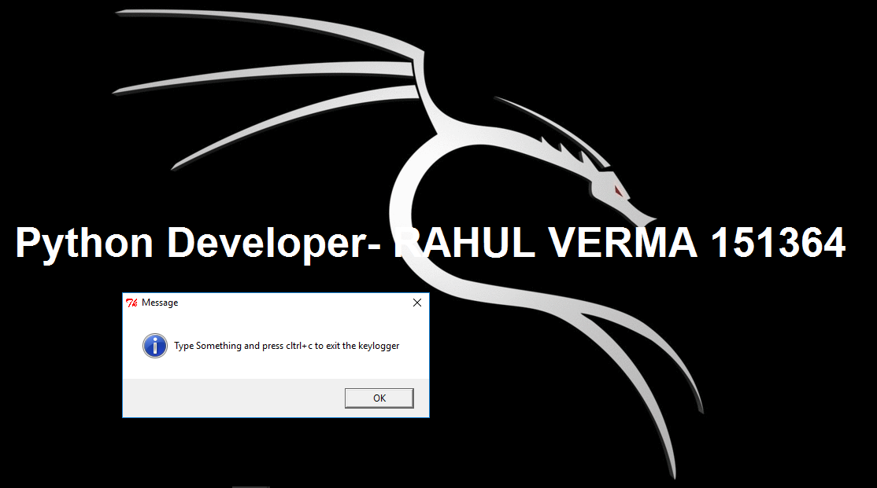

*Second part is* ***key logger*** *that records your key strokes and saves them in a text file on your desktop and then automatically sends them to an email address . Type anything on keyboard and press* ***control +c*** *to on the following screen of your desktop.*

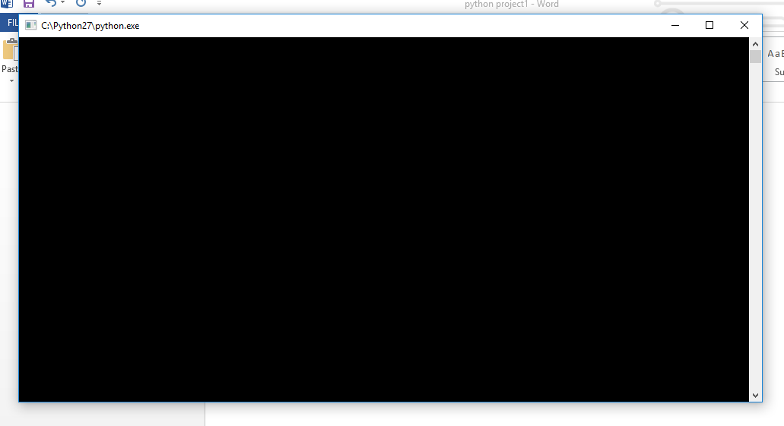

*It will then ask the mail address of the receiver and password of the sender. After entering all information a voice message will come which will ask you to wait for 2 minutes. It will then* ***automatically open up your inbox*** *,to show that mail has been sent.*

*After successful completion this message will come.*

